

ADDIS ABABA UNIVERSITY

ADDIS ABABA INSTITUTE OF TECHNOLOGY

CENTER OF INFORMATION TECHNOLOGY AND SCIENTIFIC COMPUTING

DEPARTMENT OF SOFTWARE ENGINEERING

Fundamentals of Web Design

**Lecture One Based Assignment**

**Prepared By:** - Sitota Ezra (ATR/5451/11)

**Submitted to:** - Mr. Fitsum Alemu

March 2020

**Table of Contents**

History of Internet : The evolution 1

Observation of popular websites and assessment of their changes 3

Google 3

Github 3

Amazon 4

You tube 5

Twitter 7

12 Categories of Websites 8

Portal Websites 8

News Websites 8

Informational Websites 9

Marketing Websites 9

Educational Websites 9

Entertainment Websites 10

Advocacy Websites 10

Blog Websites 10

Wiki Websites 11

Social Network Websites 11

Content Agrregator Websites 11

Personal Websites 12

Website Evaluation 12

Guidelines for evaluating websites 12

Examples of Website Evaluation 13

References 16

# History of Internet : The evolution

The Internet started in the 1960s as a way for government researchers to share information. Computers in the early '60s were large and immobile meaning in order to use the information stored in the computers users had to be present at the site of the computer and have magnetic tapes to copy the information. This was a serious problem as it took much time and wasted energy.

In August 1962 J.C.R. Licklider of MIT came up with the “Galactic Network” concept that described globally interconnected set of computers through which everyone could quickly access data and programs from any site.

With the launch of the sputnik by the Soviet Union in the late 60’s, the US department of Defense came up with the ARPANET (Advanced Research Projects Agency Network) combining the concept of galactic networks with the idea of packets. ARPANET was a great success but membership was limited to certain academic and research organizations who had contracts with the Defense Department. On the October 29, 1969, computers at Stanford and UCLA connected for the first time. In 1970, MIT, Harvard and BBN were able to connect to the ARPANET network.

In 1971, the development of email by Ray Tomlinson and the development of e-books by Michael Hart also contributed to the development of the internet we use nowadays.

An internetwork that worked around a transmission control protocol (which eventually became TCP/IP) linked ARPANET like networks together in 1974.

January 1, 1983 was the deadline for Arpanet computers to switch over to the standard communication protocol called Transfer Control Protocol/Internetwork (TCP/IP) protocols developed by Vinton Cerf. This day is considered as the official birthday of the Internet.

The domain name system was created in 1984 along with the first Domain Name Servers (DNS). DNS servers allowed Internet users to type in an easy-to-remember domain name and then converted it to the IP address automatically.

By 1987, there were nearly 30,000 hosts on the Internet. The original Arpanet protocol had been limited to 1,000 hosts, but the adoption of the TCP/IP standard made larger numbers of hosts possible.

In 1989, Tim Berners-Lee brought about the proposal for the World Wide Web. After working on the standards for HTML, HTTP, and URLs, the first web page was created in 1991. Subsequently, first graphical web browser (Mosaic) was open for the general public in 1993.

After that, the White House and the United Nations came online, marking the beginning of the .gov and .org domain names, the web was commercialized, Java and were first introduced to the public in 1995.

Google went live in 1998 revolutionizing the way in which people find information online, Wikipedia launched in 2001, Social media websites start to emerge with the launch of Facebook in 2004 and You Tube streaming video for the masses for free.

YouTube launched in 2005, bringing free online video hosting and sharing to the public masses.

The invention of the IPhone in 2007 was the door to the era of the mobile web which is still growing currently.

# Observation of popular websites and assessment of their changes

## Google

**URL**: <https://www.google.com/>

**Year launched:** 1996

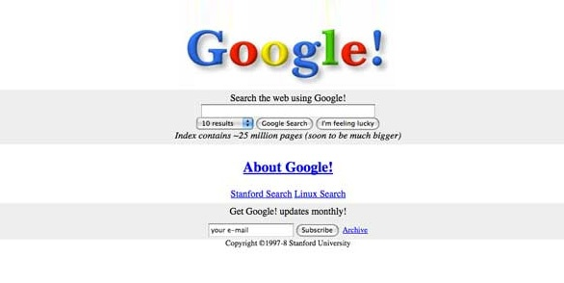

**Current look:**

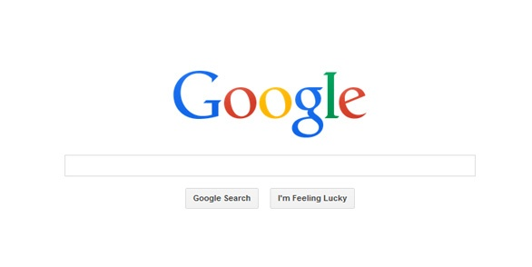

**Changes Observed:** Page got simpler with only the logo and a single search bar.

## Github

**URL:** <https://github.com/>

**Year launched:** 2008

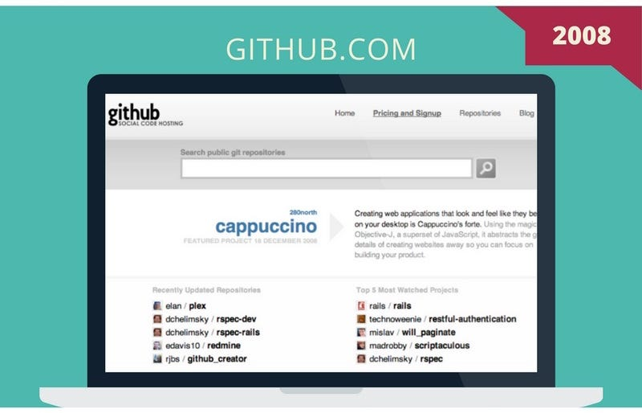

**Current look:**

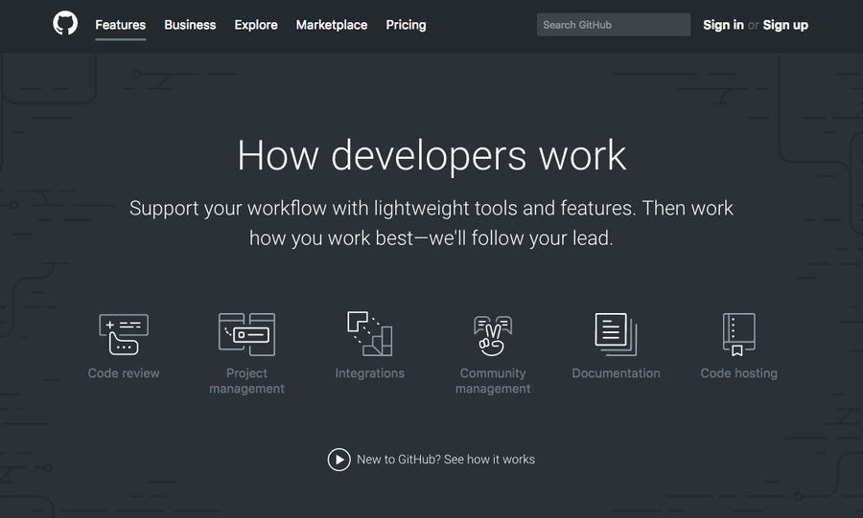

**Changes observed:** The code sharing platform has upgraded to a better user interface platform to help collaborate better and build software.

## Amazon

**URL:** <https://www.amazon.com/>

**Year launched:** 1995

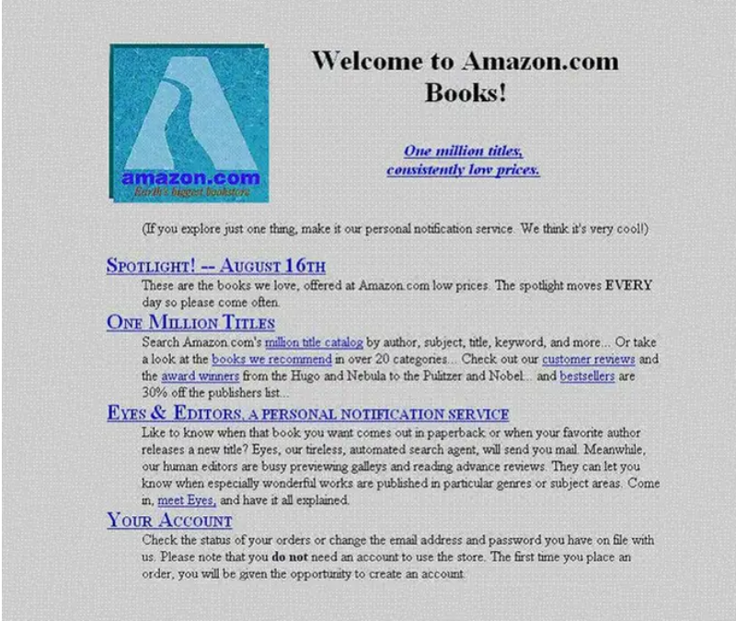

**Current look:**

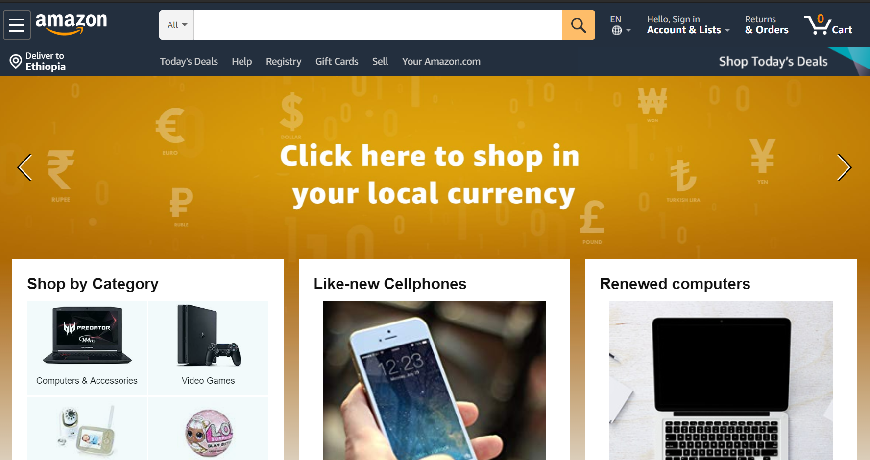

**Changes Obsereved:** they have managed to upgrade from an only text based website to a much better one that involves graphical user interaction and helps users view the products they buy easily

## You tube

**URL:** <https://www.youtube.com/>

**Year launched:** 2005

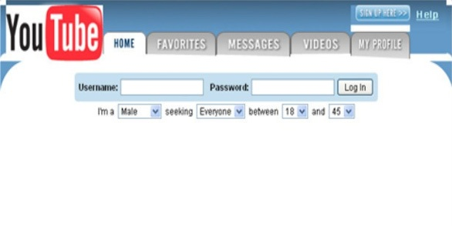

**Current look:**

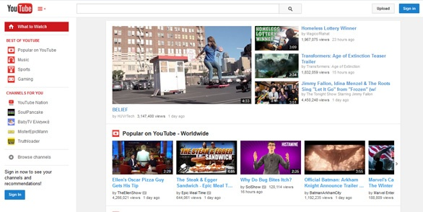

**Changes observed:** they have changed their look a little to address user needs in a better way and recommend content based on user searches.

## Twitter

**URL:** <https://twitter.com/>

**Year launched:** 2006

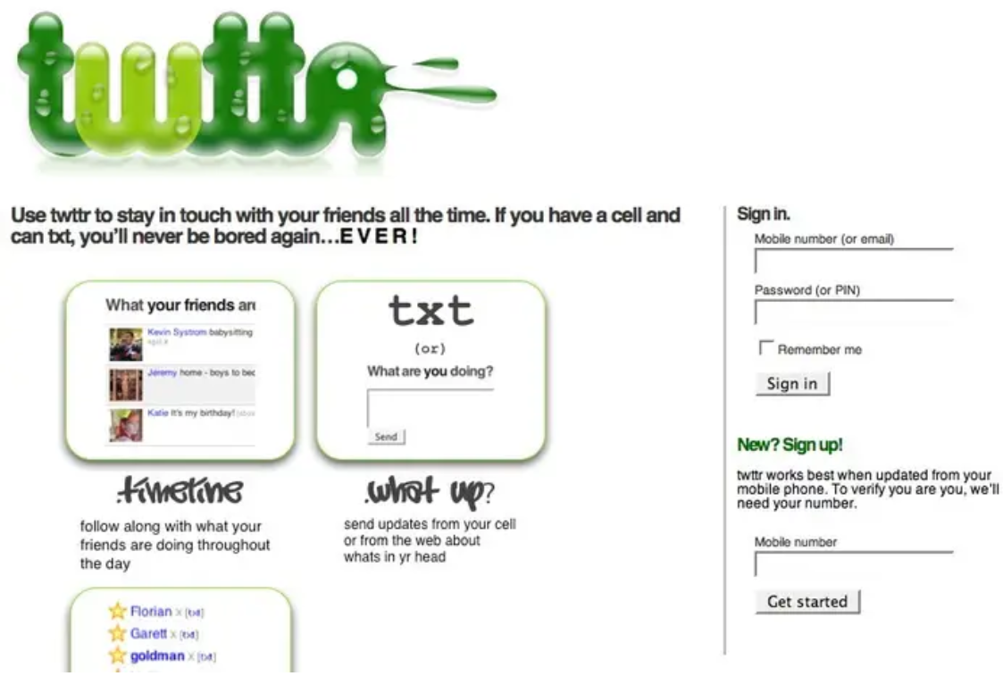

**Current look:**

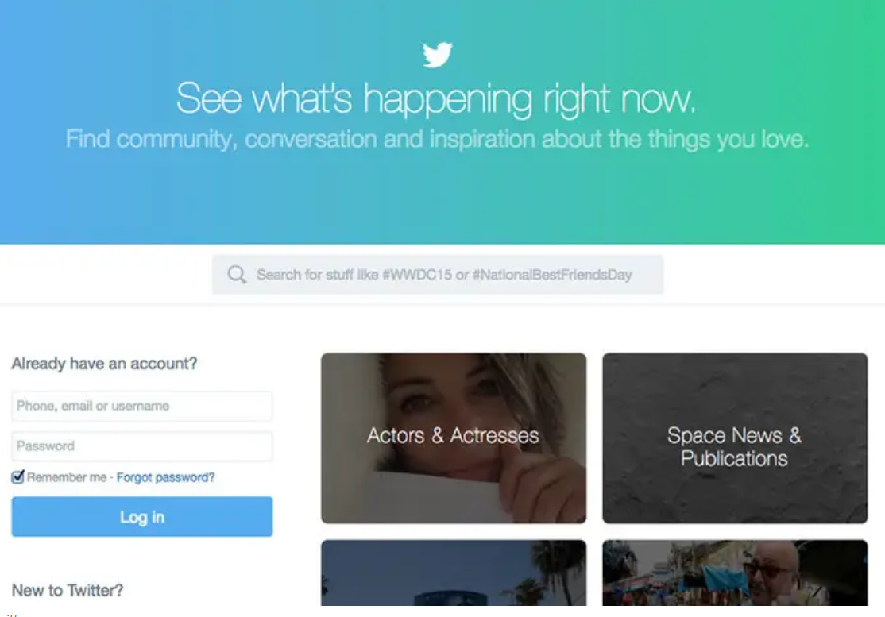

**Changes observed:** They redesigned their signup page to improve the process.

# 12 Categories of Websites

The 12 categories of websites are: Portal, News, Informational, Marketing, Educational, Entertainment, Advocacy, Blog, Wiki, Social Network, Content Aggregator and Personal.

## Portal Websites

* Santander Bank which is a retail banking portal (<https://www.santanderbank.com/us/>) that includes several retail and banking features to open new accounts and manage day to day banking operations.
* Addis Ababa University Institute of Technology is a student and faculty portal (<http://www.aait.edu.et/>) that aids the registrar office in processes of registration. It also offers services to students as they can fill in cost sharing forms and view their grades online.
* London Borough of Camden is a local government portal (<http://www.camden.gov.uk/>) that provides a personalized online experience for citizens and local business with services ranging from social care to housing control.
* AutoZone is an employee portal (<http://www.autozone.com/>) which helps store employees get information about their weekly tasks, benefits and training.
* Forest Hills Pediatrics is a patient portal (<https://www.foresthillspediatrics.com/>) helps patients request for appointments and refills, print records, fill out surveys for check-ups and review growth charts.

## News Websites

Based on the eBizMBA Rank which is continually updated according to the U.S. traffic rank from Quantcast here are the top 5 popular news websites of February 2020.

* Yahoo News (<http://news.yahoo.com/>)
* Google News (<http://news.google.com/>)
* Huffington Post (<http://www.huffingtonpost.com/>)
* CNN (<http://www.cnn.com/>)
* New York Times (<http://www.nytimes.com/>)

## Informational Websites

* Trip Advisor (<https://www.tripadvisor.com/>) is a city guide search that helps to find best city restaurants and things to do while travelers are on the road.
* HowStuffWorks (<https://www.imdb.com/>) great encyclopedia in how things really work with detailed content and well-designed illustrations to help readers understand easily.
* IMDb (<https://www.imdb.com/>) has information about movies and people in the entertainment industry.
* Encyclopedia Britannica (<https://www.britannica.com/>) online encyclopedia service.
* WebMD (<https://www.webmd.com/>) has information on health conditions, symptoms, medicine and procedures.

## Marketing Websites

* Urban Decay All Access (<https://www.urbandecay.com/ud-all-access>) content hub that gives makeup devotees makeup tips and advice.
* American Express Open Forum (<https://www.americanexpress.com/us/small-business/openforum/explore/>) content hub of articles and podcasts targeting small business owners.
* Grow From Acorns (<https://grow.acorns.com/>) an online magazine that helps he millennial section of the population to start investing
* P&G Everyday (<https://www.pgeveryday.com/>) produces products in many categories from home to personal care and from adults to children.
* Casper Mattress (<http://blog.casper.com/>) entirely based online, the brand only sells its mattresses through the website.

## Educational Websites

Some of the top websites that provide educational help to students include:

* Edx (<https://www.edx.org/>)
* Khan Academy (<https://www.khanacademy.org/>)
* MIT OpenCourseWare (<https://ocw.mit.edu/index.htm>l)
* Chegg (<https://www.chegg.com/>)
* Geeks for Geeks (<https://www.geeksforgeeks.org/>)

## Entertainment Websites

Top ranking websites for arts and entertainment include:

* YouTube (https://www.youtube.com/) a music and video streaming service
* Netflix (<https://www.netflix.com/>) an online movie and TV show streaming service
* Spotify (<https://www.spotify.com/>) a digital music service with access to millions of songs.
* Wattpad (<https://www.wattpad.com/>) an online reading service that connects a global community through the power of story.
* 9gag (<https://9gag.com/>) a way to explore through popular memes, awesome GIFs and viral videos over the internet.

## Advocacy Websites

* Food for life Global (<https://ffl.org/>) works on liberal distribution of pure plant based meals.
* Spark Action (<https://sparkaction.org/>) works on campaigns to make a difference and take action on many inspirational topics.
* Women of Color Network (<https://wocninc.org/>) advocates women in leadership roles.
* Alliance for Justice (<https://www.afj.org/>) which are committed in creating a just, free and equitable society for all.
* Hope for Alzheimer’s Act (<http://act.alz.org/site/PageNavigator/Advocacy_PublicPolicy/HOPEforAlzheimersAct.html>) work on raising awareness about the disease

## Blog Websites

* Migrationology (<https://migrationology.com/>) is a food travel blog where people who love to eat come for delicious food from around the world.
* Medical News Today (<https://www.medicalnewstoday.com/>) is a health blog that provides real and practical advice to help readers prevent illness.
* Training Design by Cathy Moore (<https://blog.cathy-moore.com/>) is an e-learning blog that gives tips and tools to help with workshops and trainings.
* GoNintendo (<http://www.gonintendo.com/>) is a tech and gaming blog that gives viewers with feed about Nintendo gaming, Wii or DS.
* Aha Parenting Blog (<https://www.ahaparenting.com/blog>) gives parents advice on the upbrining of their children.

## Wiki Websites

* WikiHow (<https://www.wikihow.com/Main-Page>) for anyone who wants to learns how to do something
* WikiTravel (<https://wikitravel.org/en/Main_Page>) for making travel plans
* Wiki Books (<https://en.wikibooks.org/wiki/Main_Page>) for accesing open context textbooks, annotated texts, instructional guides and manuals
* Wiktionary (<https://en.wiktionary.org/wiki/Wiktionary:Main_Page>), a multilingual dictionary for over six million words.
* Wikipedia (<https://en.wikipedia.org/wiki/Main_Page>) , a free online encyclopedia.

## Social Network Websites

Some of the popular social media sites include:

* Facebook (<http://www.facebook.com/>) a way to coonect with friends, family and other people you know by sharing photos, videos and sending messages.
* Whatsapp (<https://www.whatsapp.com/>) a fast and simple way to send secure messages and calls over the internet
* Tumblr (<http://tumblr.com/>) a way to connect your interests with people
* Instagram (<http://www.instagram.com/>) a fun and creative way to capture, edit and share photos.
* Twitter (<http://twitter.com/>) a fast way to find latest news ,world events and join the conversation.

## Content Agrregator Websites

Content Aggregator websites are websites that gather content from all over the internet and aggregate it into an easy find location. Examples of content aggregator websites include:

* Alltop (<https://alltop.com/>)
* Popurls (<http://m.popurls.com/>)
* The Web List (<https://theweblist.net/>)
* WP News Desk (<http://wpnewsdesk.com/>)
* Blog Engage (<http://www.blogengage.com/>)

## Personal Websites

* Raf Derolez (<https://rafaelderolez.com/>)
* Quinton Harris (<http://quinntonharris.strikingly.com/>)
* Sean Halpin (<http://seanhalpin.io/>)
* Verena Michelitsch (<https://verenamichelitsch.com/>)
* Melanie Daveid (<http://melaniedaveid.com/>)

# Website Evaluation

## Guidelines for evaluating websites

Guidelines for evaluating the value of a website include:

* Authority: checking if the person, institution or agency that has hosted the website has the qualifications and knowledge to do so. He page should list author credentials and a domain name (.edu, .gov, .org, or .net)
* Purpose: the purpose of the information presented in the website should be clear whether it is to inform, entertain, state an opinion or something else. Checking the URL can also help indicate the purpose of the website.
* Coverage: whether the site is selective or comprehensive and the extent of content coverage in depth. Users should also be able to view content without being limited to fees, browser technology or software requirement.
* Currency: refers to how current is the information presented and how often the site is updated and maintained.
* Accuracy and Reliability of the information: checking for basic rules of grammar, spelling and composition and whether references are included. Information including who developed the site, contact information and credentials should be clearly stated.
* Objectivity: what goals does the website meet and how detailed is the information. Limited advertisement is also a characteristic of an objective website
* Audience: who is the target audience (Academics, general public or children) and does the website appropriately address the target audience.

## Examples of Website Evaluation

1. **CNN**

(<https://edition.cnn.com/>)

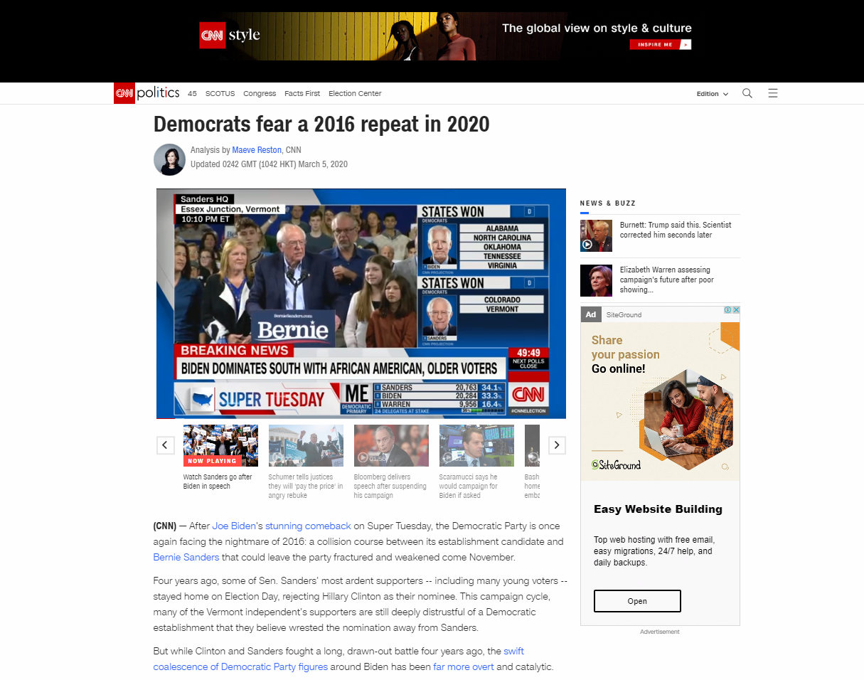

The CNN site provides publishing date and it is current. The author is a journalist with credentials that can be verifies. Contents of the website look credible and can be verified upon investigation by contacting the publisher (which is clearly stated on the footer of their page).

1. **WebMD**

(<https://www.webmd.com/>)

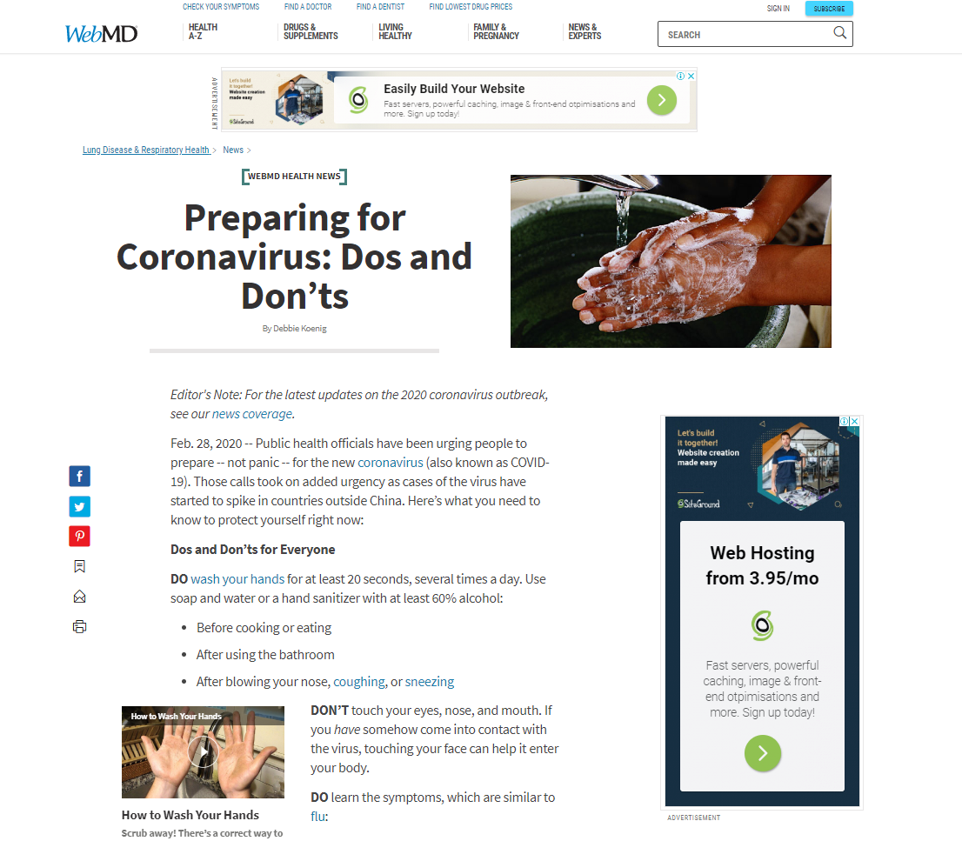

The WebMD page provides current and credible health information to its viewers. The article is also written by a journalist with contact information. The WebMD’s publisher can be taken responsible if any information on the page is found to be not credible.

1. **Nations Encyclopedia**

(<https://www.nationsencyclopedia.com/Africa/Ethiopia.html>)

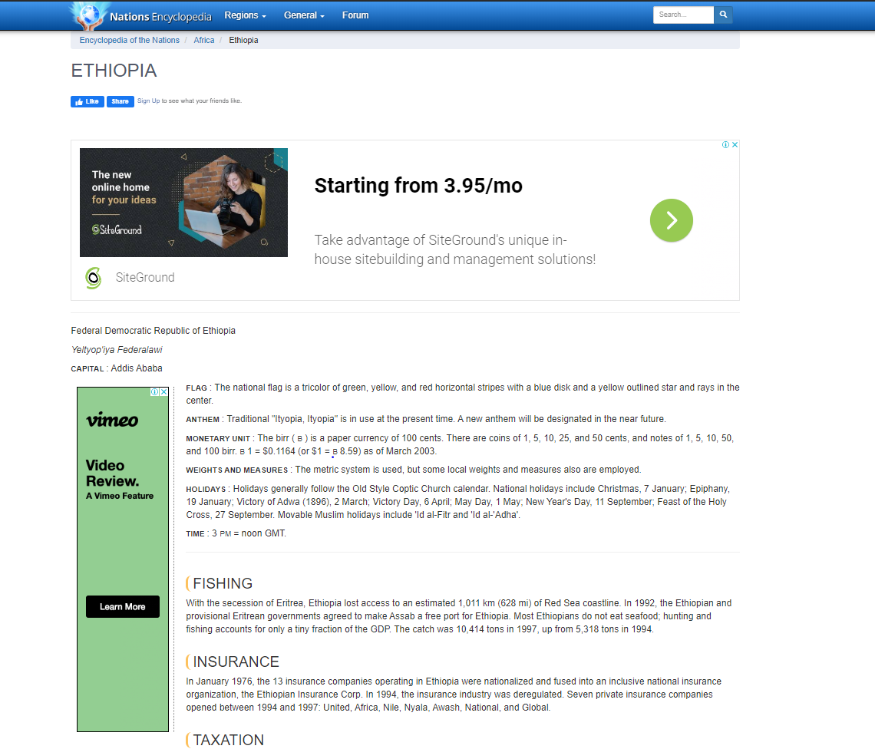

Information about the authors of this site is not given. The article does not provide a publication date and doesn’t look up to date. Citations and links on this site don’t cite their resources and also lead to other questionable sites. Hence, this website can’t be considered as a credible source.

# References

* Internet Society, <https://www.internetsociety.org/internet/history-internet/briefhistory-internet/>, Feb 28, 2020
* Web fix, <https://www.webfx.com/blog/web-design/the-history-of-the-internet-in-a-nutshell/>, Feb 28, 2020
* University System of Georgia, [https://www.usg.edu/galileoskills/unit07/internet07_02 .phtml](https://www.usg.edu/galileoskills/unit07/internet07_02%20.phtml), Feb 28, 2020
* Intechnic,<https://www.intechnic.com/blog/what-popular-websites-used-to-look-like/>,Mar 05, 2020
* Insider, <https://www.insider.com/then-and-now-what-websites-used-to-look-like2017-8> , Mar 05, 2020
* Creative pool, <https://creativepool.com/magazine/inspiration/what-famous-websites-used-to-look-like.2340> , Mar 05, 2020
* Way back Machine, <http://web.archive.org/>, Mar 05, 2020
* Life Ray, <https://liferay.dev/blogs/-/blogs/15-awesome-web-portal-examples>, Mar 03, 2020
* Ebizma, <http://www.ebizmba.com/articles/news-websites>, Mar 03, 2020
* Topyaps, <https://topyaps.com/best-13-informative-websites/>, Mar 03, 2020
* Izea, <https://izea.com/2018/02/21/content-marketing-website-examples/>, Mar 03, 2020
* India Today, [https://www.indiatoday.in/education-today/featurephilia/story/free education-953499-2017-01-06](https://www.indiatoday.in/education-today/featurephilia/story/free%20education-953499-2017-01-06), Mar 03, 2020
* Similar Web, [https://www.similarweb.com/top-websites/category/arts-and entertainment](https://www.similarweb.com/top-websites/category/arts-and%20entertainment), Mar 03, 2020
* University of Wisconsin, [https://www.library.wisc.edu/socialwork/research-help/ social-issues-websites/advocacy-websites/](https://www.library.wisc.edu/socialwork/research-help/%20social-issues-websites/advocacy-websites/), Mar 03, 2020
* First site guide, <https://firstsiteguide.com/examples-of-blogs/>, Mar 03, 2020
* Make use of, <https://www.makeuseof.com/tag/13-popular-wikis-that-actually-work/>, Mar 03, 2020
* Make a website hub, <https://makeawebsitehub.com/social-media-sites/>, Mar 03, 2020
* Wpmayor, <https://wpmayor.com/6-best-examples-content-aggregator-websites/>, Mar 03, 2020
* Hupspot, <https://blog.hubspot.com/marketing/best-personal-websites>, Mar 03, 2020
* <https://cdn.dal.ca/content/dam/dalhousie/pdf/library/CoreSkills/6_Criteria_for_Websites.pdf>, Mar 04, 2020
* CCC online library, <https://ccconline.libguides.com/c.php?g=242130&p=1609638>, Mar 04, 2020
* University of Edinburgh, <https://www.ed.ac.uk/information-services/library-museum-gallery/finding-resources/library-databases/databases-overview/evaluating-websites>, Mar 04, 2020
* Easy bib, <https://media.easybib.com/ebook/mla_websiteeval.pdf>, Mar 04, 2020